Exercise 1(A) - Additional Task 1
Initial Setup 1
1. Mechanical System 1
2. Electrical System 2
3. Electromechanical System 4

Initial Setup
close all;
clear;
clc;

1. Mechanical System
F = str2double(inputdlg('Enter force value: ')); %300
M = str2double(inputdlg('Enter mass value: ')); %750
B = str2double(inputdlg('Enter dashpot constant value: ')); %30
K = str2double(inputdlg('Enter spring constant value: ')); %0
s = tf('s');
G = 1/((M*s^2)+(B*s)+K);
System = F*G;
figure('Name','Response of Mechanical System','NumberTitle','off');
pause(0.00001);
frame_h = get(handle(gcf),'JavaFrame');
set(frame_h,'Maximized',1);
% Impulse response
subplot(3,2,1);
impulse(System);
title('Impulse Response of Mechanical System');
xlabel('Time');
ylabel('Displacement');
% Step response
subplot(3,2,2);
step(System);
title('Step Response of Mechanical System');
xlabel('Time');
ylabel('Displacement');
t = 0:0.1:10; % Time vector
% Ramp response
u = t; % Ramp input
subplot(3,2,3);
lsim(System,u,t)
title('Ramp Response of Mechanical System');
xlabel('Time');
ylabel('Displacement');
% Parabolic response
u = (t.^2)/2; % Parabolic input
subplot(3,2,4);
lsim(System,u,t)
title('Parabolic Response of Mechanical System');
xlabel('Time');
ylabel('Displacement');
% Exponential response
u = exp(-t); % Exponential input
subplot(3,2,5);
lsim(System,u,t)
title('Exponential Response of Mechanical System');
xlabel('Time');
ylabel('Displacement');
% Sinusoidal response
u = sin(t); % Parabolic input
subplot(3,2,6);
lsim(System,u,t)
title('Sinusoidal Response of Mechanical System');
xlabel('Time');
ylabel('Displacement');
Warning: figure JavaFrame property will be obsoleted in a future release. For
more information see <a href="http://www.mathworks.com/javaframe">the JavaFrame
resource on the MathWorks web site</a>.
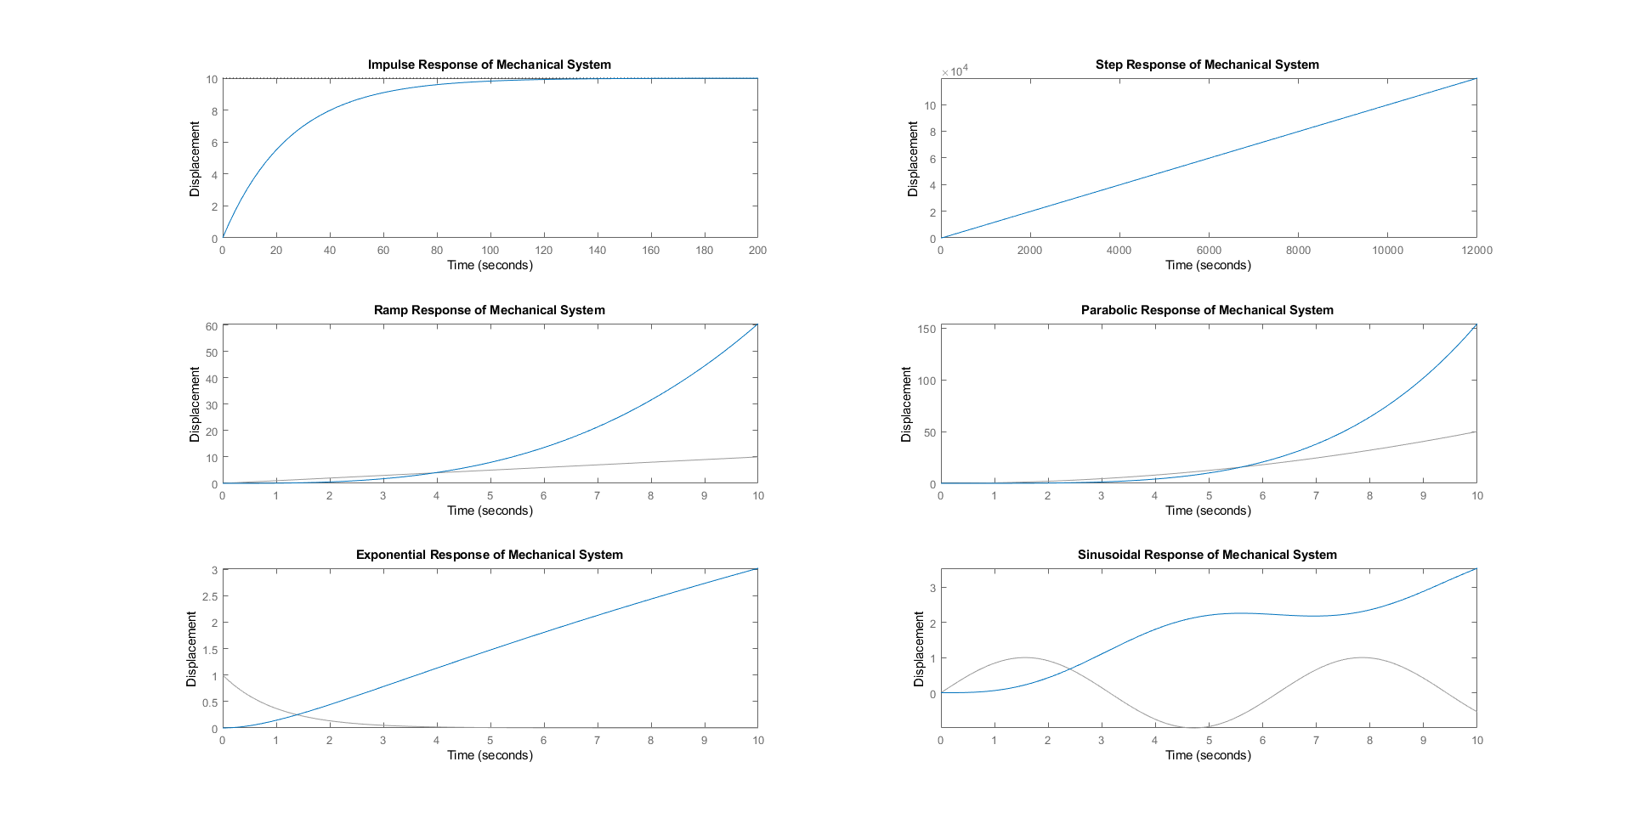

2. Electrical System
V = str2double(inputdlg('Enter voltage value: ')); %12
R = str2double(inputdlg('Enter resistance value: ')); %1e3
C = str2double(inputdlg('Enter capacitance value: ')); %160e-6
s = tf('s');
G = 1/(((R^2)*(C^2)*(s^2))+(3*R*C*s)+1);
System = V*G;
figure('Name','Response of Electrical System','NumberTitle','off');
pause(0.00001);
frame_h = get(handle(gcf),'JavaFrame');
set(frame_h,'Maximized',1);
% Impulse response
subplot(3,2,1);
impulse(System);
title('Impulse Response of Electrical System');
xlabel('Time');
ylabel('Voltage');
% Step response
subplot(3,2,2);
step(System);
title('Step Response of Electrical System');
xlabel('Time');
ylabel('Voltage');
t = 0:0.1:10; % Time vector
% Ramp response
u = t; % Ramp input
subplot(3,2,3);
lsim(System,u,t)
title('Ramp Response of Electrical System');
xlabel('Time');
ylabel('Voltage');
% Parabolic response
u = (t.^2)/2; % Parabolic input
subplot(3,2,4);
lsim(System,u,t)
title('Parabolic Response of Electrical System');
xlabel('Time');
ylabel('Voltage');
% Exponential response
u = exp(-t); % Exponential input
subplot(3,2,5);
lsim(System,u,t)
title('Exponential Response of Electrical System');
xlabel('Time');
ylabel('Voltage');
% Sinusoidal response
u = sin(t); % Parabolic input
subplot(3,2,6);
lsim(System,u,t)
title('Sinusoidal Response of Electrical System');
xlabel('Time');
ylabel('Voltage');
Warning: figure JavaFrame property will be obsoleted in a future release. For
more information see <a href="http://www.mathworks.com/javaframe">the JavaFrame
resource on the MathWorks web site</a>.
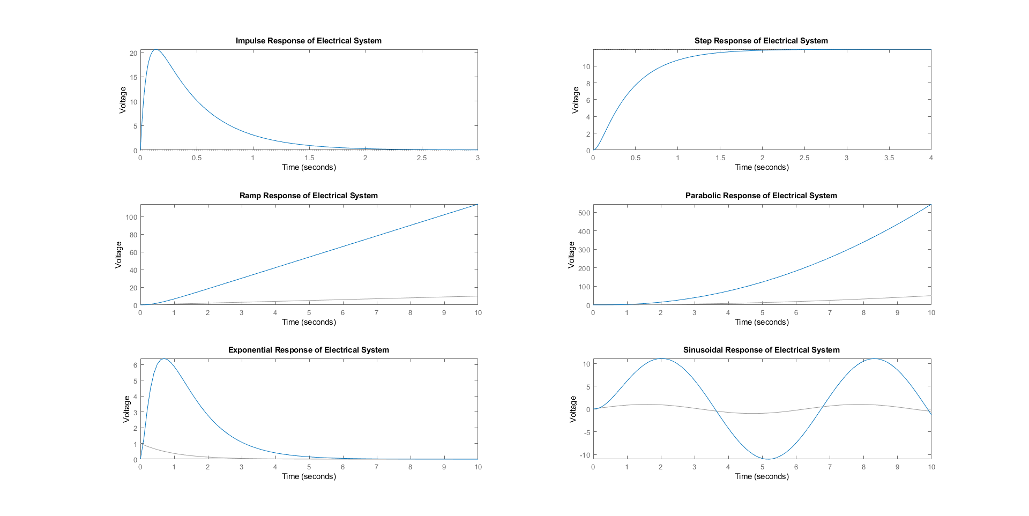

3. Electromechanical System
Va = str2double(inputdlg('Enter armature voltage value: ')); %12
Ra = str2double(inputdlg('Enter armature resistance value: ')); %4.38
La = str2double(inputdlg('Enter armature inductance value: ')); %2.15e-3
J = str2double(inputdlg('Enter inertia value: ')); %2.2e-4
B = str2double(inputdlg('Enter damping constant value: ')); %0.4
Kt = str2double(inputdlg('Enter torque constant value: ')); %1.94
Kb = str2double(inputdlg('Enter back e.m.f. constant value: ')); %1.43
s = tf('s');
G = Kt/(((Ra+(La*s))*((J*s^2)+(B*s)))+(Kt*Kb*s));
System = Va*G;
figure('Name','Response of Electromechanical System','NumberTitle','off');
pause(0.00001);
frame_h = get(handle(gcf),'JavaFrame');
set(frame_h,'Maximized',1);
% Impulse response
subplot(3,2,1);
impulse(System);
title('Impulse Response of Electromechanical System');
xlabel('Time');
ylabel('Angular Displacement');
% Step response
subplot(3,2,2);
step(System);
title('Step Response of Electromechanical System');
xlabel('Time');
ylabel('Angular Displacement');
t = 0:0.1:10; % Time vector
% Ramp response
u = t; % Ramp input
subplot(3,2,3);
lsim(System,u,t)
title('Ramp Response of Electromechanical System');
xlabel('Time');
ylabel('Angular Displacement');
% Parabolic response
u = (t.^2)/2; % Parabolic input
subplot(3,2,4);
lsim(System,u,t)
title('Parabolic Response of Electromechanical System');
xlabel('Time');
ylabel('Angular Displacement');
% Exponential response
u = exp(-t); % Exponential input
subplot(3,2,5);
lsim(System,u,t)
title('Exponential Response of Electromechanical System');
xlabel('Time');
ylabel('Angular Displacement');
% Sinusoidal response
u = sin(t); % Parabolic input
subplot(3,2,6);
lsim(System,u,t)
title('Sinusoidal Response of Electromechanical System');
xlabel('Time');
ylabel('Angular Displacement');
Warning: figure JavaFrame property will be obsoleted in a future release. For
more information see <a href="http://www.mathworks.com/javaframe">the JavaFrame
resource on the MathWorks web site</a>.
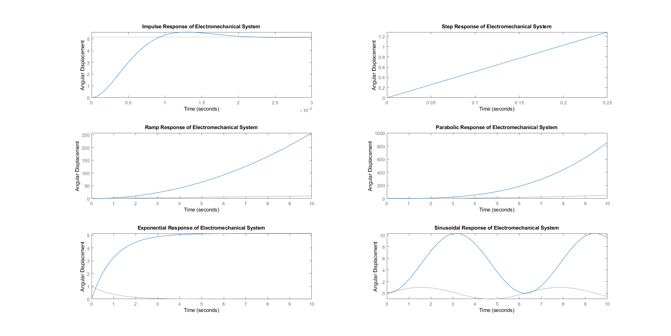
Published with MATLAB® R2018a

